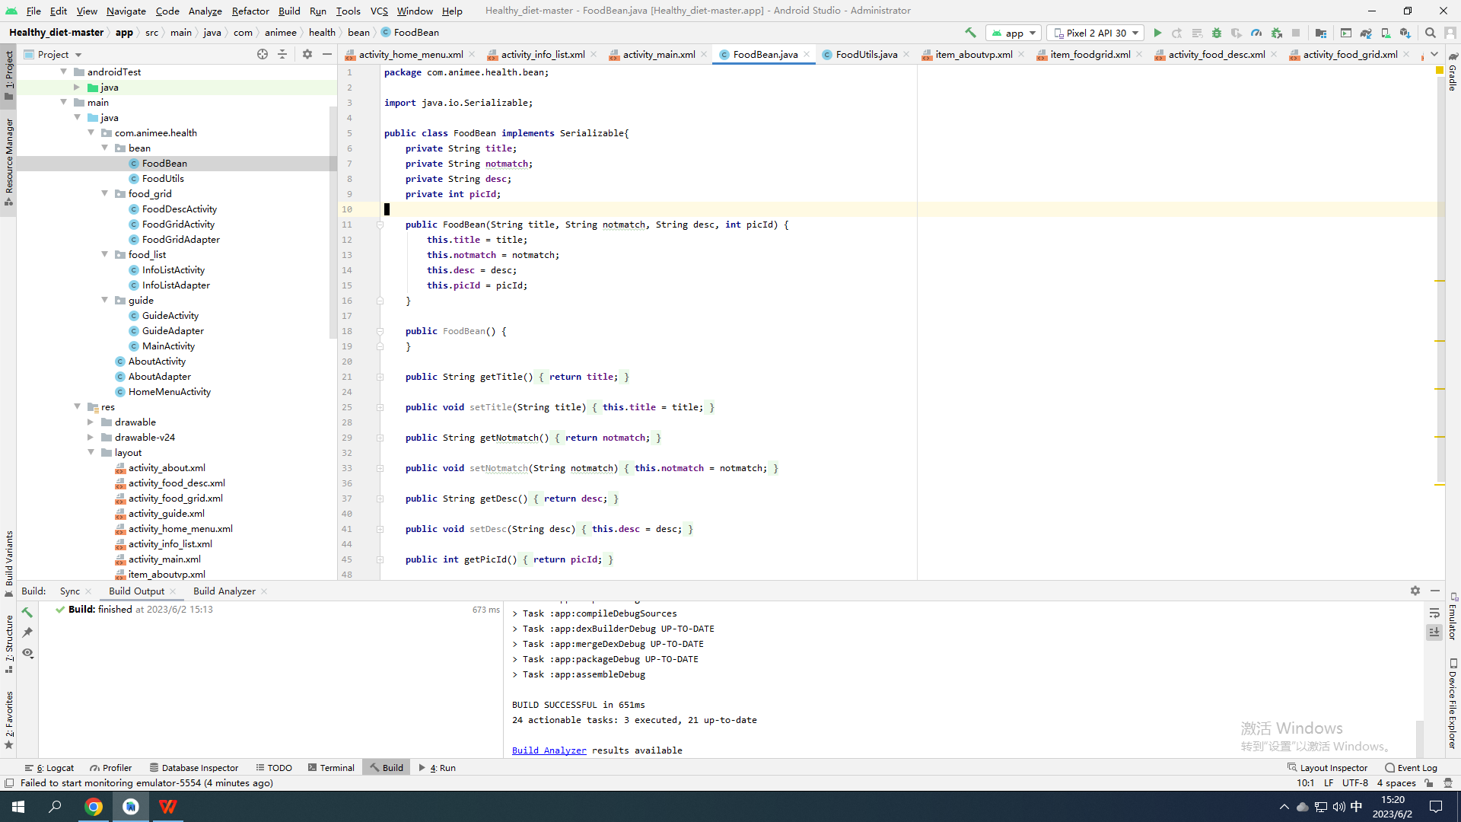

**package** com.animee.health.bean;  
  
**import** java.io.Serializable;  
  
**public class** FoodBean **implements** Serializable{  
 **private** String **title**;  
 **private** String **notmatch**;  
 **private** String **desc**;  
 **private int picId**;  
  
 **public** FoodBean(String title, String notmatch, String desc, **int** picId) {  
 **this**.**title** = title;  
 **this**.**notmatch** = notmatch;  
 **this**.**desc** = desc;  
 **this**.**picId** = picId;  
 }  
  
 **public** FoodBean() {  
 }  
  
 **public** String getTitle() {  
 **return title**;  
 }  
  
 **public void** setTitle(String title) {  
 **this**.**title** = title;  
 }  
  
 **public** String getNotmatch() {  
 **return notmatch**;  
 }  
  
 **public void** setNotmatch(String notmatch) {  
 **this**.**notmatch** = notmatch;  
 }  
  
 **public** String getDesc() {  
 **return desc**;  
 }  
  
 **public void** setDesc(String desc) {  
 **this**.**desc** = desc;  
 }  
  
 **public int** getPicId() {  
 **return picId**;  
 }  
  
 **public void** setPicId(**int** picId) {  
 **this**.**picId** = picId;  
 }  
}

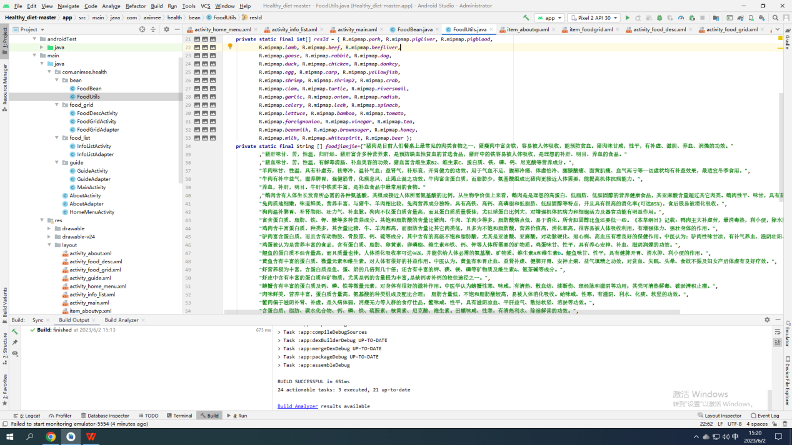

**package** com.animee.health.bean;  
  
**import** com.animee.health.R;  
**import** com.animee.health.bean.FoodBean;  
  
**import** java.util.ArrayList;  
**import** java.util.List;  
  
**public class** FoodUtils {  
 **private static final** String[] ***food*** = { **"猪肉(pork)"**, **"猪肝(pig liver)"**, **"猪血(pig blood)"**, **"羊肉(lamb)"**, **"牛肉(beef)"**, **"牛肝(cow liver)"**, **"鹅肉(goose)"**, **"兔肉(rabbit)"**, **"狗肉(dog)"**,  
 **"鸭肉(duck meet)"**, **"鸡肉(chicken)"**, **"驴肉(donkey meat)"**, **"鸡蛋(egg)"**, **"鲤鱼"**, **"黄鱼"**, **"虾"**, **"虾皮"**, **"螃蟹"**, **"蛤"**, **"鳖肉"**,  
 **"田螺"**, **"大蒜"**, **"葱"**, **"萝卜"**, **"芹菜"**, **"韭菜"**, **"菠菜"**, **"莴笋"**, **"竹笋"**, **"西红柿"**, **"洋葱"**,  
 **"醋"**, **"茶"**, **"豆浆"**, **"红糖"**, **"蜂蜜"**, **"牛奶(milk)"**, **"白酒"**, **"啤酒(beer)"** };  
 **private static final** String[] ***food1*** = { **"黄莲"**, **"荞麦 雀肉 豆芽"**, **"何首乌 地黄 黄豆 海带"**, **"醋 红豆 半夏 南瓜"**,  
 **"橄榄 板粟 韭菜 "**, **"鲇鱼 鳗鱼 柿子"**, **"狗肉 鲤鱼 柑橘"**, **"鲤鱼 绿豆"**, **"鳖"**, **"鲤鱼"**, **"金针菇"**,  
 **"豆浆 兔肉"**, **"甘草 麦冬"**, **"荞麦面 "**, **"富含维生素C的食物"**, **"红枣 黄豆"**,  
 **"梨 柿子 茄子 花生仁 石榴 香瓜 芹菜 蜂蜜 西红柿"**, **"芹菜 "**, **"鸭肉"**, **"香瓜 木耳 牛肉 蚕豆 玉米"**,  
 **"地黄 何首乌 白术"**, **"枣"**, **"橘子 木耳"**, **"黄瓜 蚬、蛤、蟹"**, **"牛肉"**, **"豆腐 鳝鱼 黄瓜"**, **"蜂蜜"**,  
 **"糖浆"**, **"白酒"**, **"蜂蜜"**, **"胡萝卜"**, **"酒"**, **"蜂蜜"**, **"竹笋"**, **"皮蛋"**, **"豆腐 韭菜"**,  
 **"钙片果汁 药物 韭菜 柠檬"**, **"胡萝卜 核桃 啤酒 红薯"**, **"海鲜"** };  
 **private static final int**[] ***resId*** = { R.mipmap.***pork***, R.mipmap.***pigliver***, R.mipmap.***pigblood***,  
 R.mipmap.***lamb***, R.mipmap.***beef***, R.mipmap.***beefliver***,  
 R.mipmap.***goose***, R.mipmap.***rabbit***, R.mipmap.***dog***,  
 R.mipmap.***duck***, R.mipmap.***chicken***, R.mipmap.***donkey***,  
 R.mipmap.***egg***, R.mipmap.***carp***, R.mipmap.***yellowfish***,  
 R.mipmap.***shrimp***, R.mipmap.***shrimp2***, R.mipmap.***crab***,  
 R.mipmap.***clam***, R.mipmap.***turtle***, R.mipmap.***riversnail***,  
 R.mipmap.***garlic***, R.mipmap.***onion***, R.mipmap.***radish***,  
 R.mipmap.***celery***, R.mipmap.***leek***, R.mipmap.***spinach***,  
 R.mipmap.***lettuce***, R.mipmap.***bamboo***, R.mipmap.***tomato***,  
 R.mipmap.***foreignonion***, R.mipmap.***vinegar***, R.mipmap.***tea***,  
 R.mipmap.***beanmilk***, R.mipmap.***brownsuger***, R.mipmap.***honey***,  
 R.mipmap.***milk***, R.mipmap.***whitespirit***, R.mipmap.***beer*** };  
 **private static final** String [] ***foodjianjie***={**"猪肉是目前人们餐桌上最常见的肉类食物之一，猪瘦肉中富含铁，容易被人体吸收，能预防贫血。猪肉味甘咸，性平，有补虚、滋阴、养血、润燥的功效。"** ,**"猪肝味甘、苦，性温，归肝经。猪肝富含多种营养素，是预防缺血性贫血的首选食品，猪肝中的铁容易被人体吸收，是理想的补肝、明目、养血的食品。"** ,**"猪血味甘、苦，性温，有解毒清肠、补血美容的功效。猪血富含维生素B2、维生素C、蛋白质、铁、磷、钙、尼克酸等营养成分。"**,  
 **"羊肉味甘、性温，具有补虚劳，祛寒冷，温补气血；益肾气，补形衰，开胃健力的功效。用于气血不足、腹部冷痛、体虚怕冷、腰膝酸痛、面黄肌瘦、血气两亏等一切虚状均有补益效果，最适宜冬季食用。"**,  
 **"牛肉有补中益气，滋养脾胃，强健筋骨，化痰息风，止渴止涎之功效。牛肉富含蛋白质，而脂肪少，氨基酸组成比猪肉更接近人体需要，能提高机体抗病能力。"**,  
 **"养血，补肝，明目。牛肝中铁质丰富，是补血食品中最常用的食物。"** ,**"鹅肉含有人体生长发育所必需的各种氨基酸，其组成接近人体所需氨基酸的比例，从生物学价值上来看，鹅肉是是理想的高蛋白、低脂肪、低胆固醇的营养健康食品，其亚麻酸含量超过其它肉类。鹅肉性平、味甘，具有益气补虚，和胃止渴的功效。"**,  
 **"兔肉质地细嫩，味道鲜美，营养丰富，与猪牛、羊肉相比较，兔肉营养成分独特，具有高铁、高钙、高磷脂和低脂肪、低胆固醇等特点，并且具有很高的消化率(可达85%)，食后极易被消化吸收。"**,  
 **"狗肉温补脾胃、补肾助阳、壮力气、补血脉。狗肉不仅蛋白质含量高，而且蛋白质质量极佳，尤以球蛋白比例大，对增强机体抗病力和细胞活力及器官功能有明显作用。"**,  
 **"富含蛋白质、脂肪、铁、钾、糖等多种营养成分。其饱和脂肪酸的含量比猪肉、牛肉、羊肉少得多，脂肪酸熔点低，易于消化。所含胆固醇比鱼还要低一些。《本草纲目》记载：鸭肉主大补虚劳，最消毒热，利小便，除水肿，消胀满，利脏腑，退疮肿，定惊痫。"**,  
 **"鸡肉含丰富蛋白质，种类多，其含量比猪、牛、羊肉都高，而脂肪含量比其它肉类低，且多为不饱和脂肪酸，营养价值高，消化率高，很容易被人体吸收利用，有增强体力、强壮身体的作用。"**,  
 **"驴肉富含蛋白质，而且含有动物胶、骨胶原、钙、硫等成分，其中含有的高级不饱和脂肪酸，尤其是亚油酸、亚麻酸，对动脉硬化、冠心病、高血压有着良好的保健作用。中医认为：驴肉性味甘凉，有补气养血、滋阴壮阳、安神去烦功效。"**,  
 **"鸡蛋被认为是营养丰富的食品，含有蛋白质、脂肪、卵黄素、卵磷脂、维生素和铁、钙、钾等人体所需要的矿物质。鸡蛋味甘、性平，具有养心安神、补血、滋阴润燥的功效。"**,  
 **"鲤鱼的蛋白质不但含量高，而且质量也佳，人体消化吸收率可达96%，并能供给人体必需的氨基酸、矿物质、维生素A和维生素D。鲤鱼味甘、性平，具有健脾开胃、消水肿、利小便的作用。"**,  
 **"黄鱼含有丰富的蛋白质、微量元素和维生素，对人体有很好的补益作用。中医认为，黄鱼有和胃止血、益肾补虚、健脾开胃、安神止痢、益气填精之功效，对贫血、失眠、头晕、食欲不振及妇女产后体虚有良好疗效。"**,  
 **"虾营养极为丰富，含蛋白质是鱼、蛋、奶的几倍到几十倍；还含有丰富的钾、碘、镁、磷等矿物质及维生素A、氨茶碱等成分。"**,  
 **"虾皮中含有丰富的蛋白质和矿物质，尤其是钙的含量极为丰富,是缺钙者补钙的较佳途径之一。"**,  
 **"螃蟹含有丰富的蛋白质及钙、磷、铁等微量元素，对身体有很好的滋补作用。中医学认为螃蟹性寒、味咸，有清热、散血结、续断伤、理经脉和滋阴等功用；其壳可清热解毒、破淤清积止痛。"**,  
 **"肉味鲜美、营养丰富，蛋白质含量高，氨基酸的种类组成及配比合理； 脂肪含量低，不饱和脂肪酸较高，易被人体消化吸收。蛤味咸、性寒，有滋阴、利水、化痰、软坚的功效。"**,  
 **"鳖肉偏于滋阴补肾、补虚。是久病体弱，消瘦无力等人群的食疗佳品。鳖味咸、性平，具有滋阴凉血、平肝益气、散结软坚、消淤等功效。"**,  
 **"含蛋白质、脂肪、碳水化合物、钙、磷、铁、硫胺素、核黄素、尼克酸、维生素。田螺味咸、性寒，有清热利水、除湿解读的功效。"**,  
 **"大蒜含有丰富的营养成分，尤其是具有独特生物活性的蒜素等含硫化合物及硒蛋白等功能成分，这些物质具有显著的医用和食用价值。中医理论认为，大蒜生者辛热、熟者甘温，可除寒湿、怯阴邪、下气暖中、消谷化积、破恶血、攻冷积。"**,  
 **"葱的主要营养成分是蛋白质、糖类、维生素A原(主要在绿色葱叶中含有)、食物纤维以及磷、铁、镁等矿物质等。中医记载：葱能发汗解表，散寒通阳，解毒散凝。主治风寒感冒轻症，痈肿疮毒，痢疾脉微，寒凝腹痛，小便不利等病症。"**,  
 **"萝卜含有丰富的碳水化合物、纤维素、维生素C及钙、磷、钾、铁等矿物质，营养丰富；萝卜还有促进新陈代谢，增进食欲的作用，对于治疗消化不良、胃脘胀满、咳嗽多痰、胸闷气喘、伤风感冒有一定的疗效。"**,  
 **"芹菜含有蛋白质、脂肪、碳水化合物、纤维素、维生素、矿物质等营养成分。其中，维生素B、P的含量较多。矿物质元素钙、磷、铁的含量更是高于一般绿色蔬菜。"**,  
 **"韭菜性温，味辛，具有补肾起阳作用，且含有大量维生素和粗纤维，能增进胃肠蠕动，治疗便秘。"**,  
 **"菠菜含水量高（90%～93%），而热量低，是镁、铁、钾和维生素A的优质来源；也是钙和维生素C的上等来源。所含的磷、锌、叶酸和维生素B6也较为丰富。菠菜中含有的维生素C能够提高铁的吸收率，并促进铁与造血的叶酸共同作用，有效地预防贫血症。"**,  
 **"莴苣含蛋白质、脂粉、碳水化合物、钙、磷、铁、胡萝卜素、及维生素B、维生素C、尤其含烟酸较多。莴苣味道清新且略带苦味，可刺激消化酶分泌，增进食欲。其乳状浆液，可增强胃液、消化腺的分泌和胆汁的分泌，从而促进消化。"**,  
 **"具有滋阴凉血、和中润肠、清热化痰、解渴除烦、清热益气、利隔爽胃、利尿通便、解毒透疹、养肝明目、消食的功效，还可开胃健脾，宽肠利膈，通肠排便，开膈豁痰，消油腻，解酒毒。"**,  
 **"番茄富含维生素C，其含有的番茄红素有利尿和抑制细菌生长的作用，是优良的抗氧化剂，多吃番茄具有抗衰老作用，使皮肤保持白皙。西红柿味酸微甘、性平，具有生津止渴，健胃消食，凉血平肝，清热解毒，降低血压之功效。"**,  
 **"洋葱所含的微量元素硒是一种很强的抗氧化剂，能清除体内的自由基，增强细胞的活力和代谢能力，具有抗衰老的功效。"**,  
 **"醋可以开胃，促进唾液和胃液的分泌，帮助消化吸收，使食欲旺盛，消食化积。醋还有很好的抑菌和杀菌作用，能有效预防肠道疾病、流行性感冒和呼吸疾病。"**,  
 **"茶叶内含化合物500种左右，有些是人体必需的营养成分。如维生素类、蛋白质、氨基酸、类脂类、糖类及矿物质元素等，对人体有较高营养价值。有些是对人体有保健和药用价值的成分，如茶多酚、咖啡碱、脂多糖等，常喝茶有利于人体健康。"**,  
 **"豆浆含有丰富的植物蛋白，磷脂，维生素B1、B2，烟酸和铁、钙等矿物质，尤其是钙的含量，虽不及豆腐高，但比其他任何乳类都丰富。豆浆是防治高血脂、高血压、动脉硬化等疾病的理想食品。"**,  
 **"红糖中所含有的葡萄糖、果糖等多种单糖和多糖类能量物质，为人体提供能量。"**,  
 **"蜂蜜含有70%以上的转化糖，能够被人体肠壁细胞直接吸收利用，没有必要经人体消化，经常服用蜂蜜，能帮助消化。"**,  
 **"牛奶的营养成分很高，牛奶中的矿物质种类也非常丰富，除了我们所熟知的钙以外，磷、铁、锌、铜、锰、钼的含量都很多。牛奶是人体钙的最佳来源，而且钙磷比例非常适当，利于钙的吸收。牛奶中含组成人体蛋白质的氨基酸有20种，其中有8种是人体本身不能合成的，为必需氨基酸，牛奶是人类最理想的天然食品。"**,  
 **"白酒主要由水乙醇和少量微量元素组成。夜晚服用少量的白酒，可平缓的促进血液循环，起到催眠作用。饮少量白酒可刺激胃液分泌与唾液分泌，因而起到健胃和止疼痛、利小便及驱虫的作用。白酒味苦、甘、辛，性温，有毒，入心、肝、肺、胃经。"**,  
 **"啤酒营养丰富，其中含有丰富的氨基酸，是原料大麦含有的蛋白质经过酶的作用分解而产生的。且啤酒中还含有多种维生素。适量饮啤酒有强心、利尿、健胃的功效。"**};  
  
 **public static** List<FoodBean> getAllFoodList(){  
 List<FoodBean>list = **new** ArrayList<>();  
 **for** (**int** i = 0; i < ***food***.**length**; i++) {  
 FoodBean bean = **new** FoodBean(***food***[i],***food1***[i],***foodjianjie***[i],***resId***[i]);  
 list.add(bean);  
 }  
 **return** list;  
 }  
}

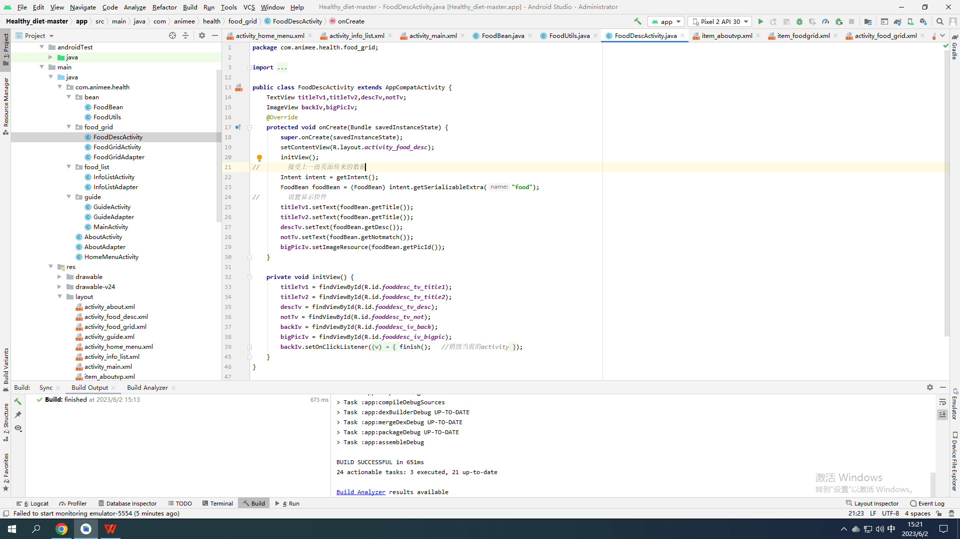

**package** com.animee.health.food_grid;  
  
**import** android.content.Intent;  
**import** android.support.v7.app.AppCompatActivity;  
**import** android.os.Bundle;  
**import** android.view.View;  
**import** android.widget.ImageView;  
**import** android.widget.TextView;  
  
**import** com.animee.health.R;  
**import** com.animee.health.bean.FoodBean;  
  
**public class** FoodDescActivity **extends** AppCompatActivity {  
 TextView **titleTv1**,**titleTv2**,**descTv**,**notTv**;  
 ImageView **backIv**,**bigPicIv**;  
 @Override  
 **protected void** onCreate(Bundle savedInstanceState) {  
 **super**.onCreate(savedInstanceState);  
 setContentView(R.layout.***activity_food_desc***);  
 initView();  
*// 接受上一级页面传来的数据* Intent intent = getIntent();  
 FoodBean foodBean = (FoodBean) intent.getSerializableExtra(**"food"**);  
*// 设置显示控件* **titleTv1**.setText(foodBean.getTitle());  
 **titleTv2**.setText(foodBean.getTitle());  
 **descTv**.setText(foodBean.getDesc());  
 **notTv**.setText(foodBean.getNotmatch());  
 **bigPicIv**.setImageResource(foodBean.getPicId());  
 }  
  
 **private void** initView() {  
 **titleTv1** = findViewById(R.id.***fooddesc_tv_title1***);  
 **titleTv2** = findViewById(R.id.***fooddesc_tv_title2***);  
 **descTv** = findViewById(R.id.***fooddesc_tv_desc***);  
 **notTv** = findViewById(R.id.***fooddesc_tv_not***);  
 **backIv** = findViewById(R.id.***fooddesc_iv_back***);  
 **bigPicIv** = findViewById(R.id.***fooddesc_iv_bigpic***);  
 **backIv**.setOnClickListener(**new** View.OnClickListener() {  
 @Override  
 **public void** onClick(View v) {  
 finish(); *//销毁当前的activity* }  
 });  
 }  
}

0

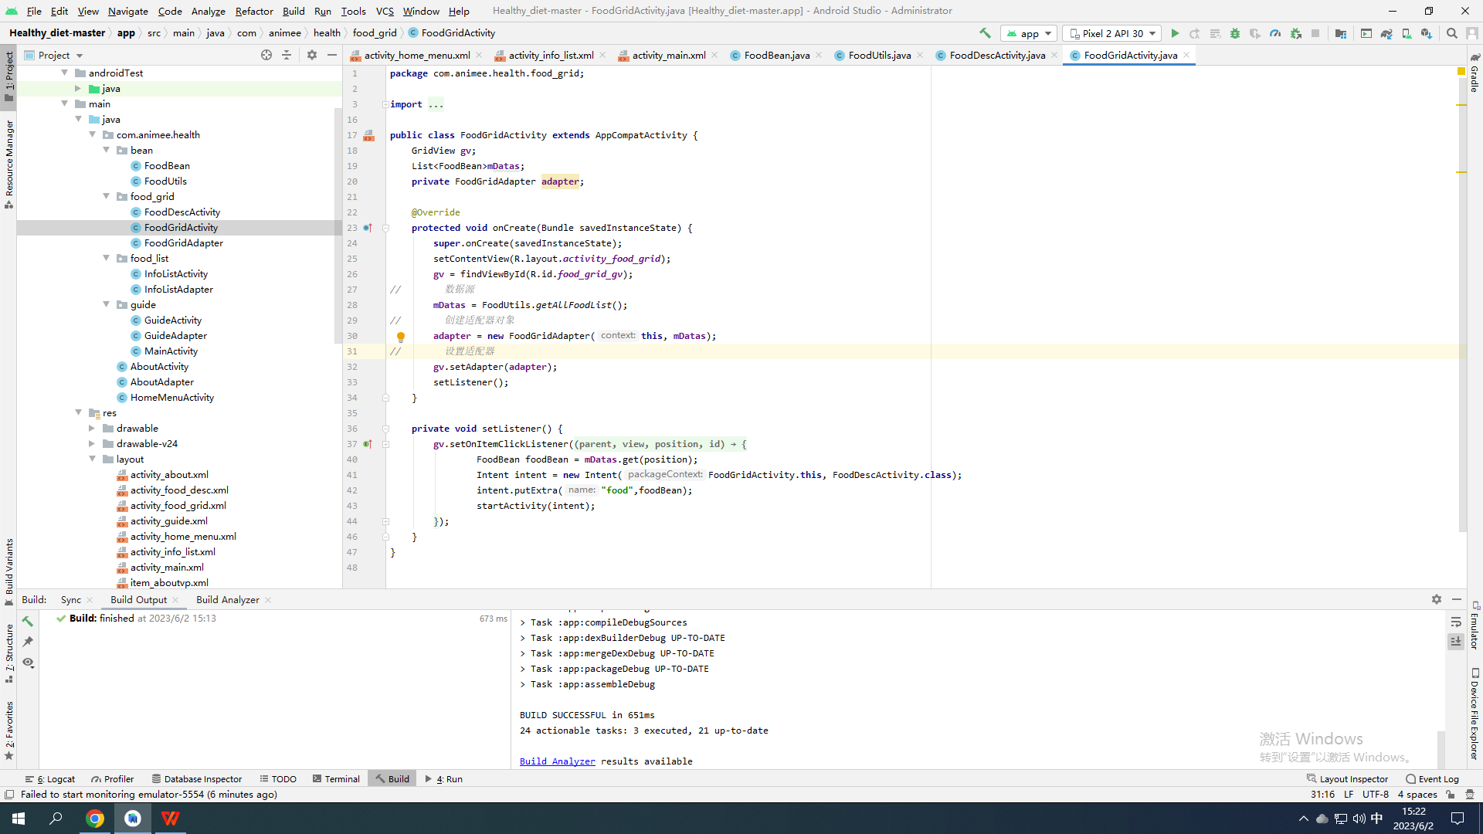

**package** com.animee.health.food_grid;  
  
**import** android.content.Intent;  
**import** android.support.v7.app.AppCompatActivity;  
**import** android.os.Bundle;  
**import** android.view.View;  
**import** android.widget.AdapterView;  
**import** android.widget.GridView;  
  
**import** com.animee.health.R;  
**import** com.animee.health.bean.FoodBean;  
**import** com.animee.health.bean.FoodUtils;  
**import** com.animee.health.food_list.InfoListActivity;  
  
**import** java.util.List;  
  
**public class** FoodGridActivity **extends** AppCompatActivity {  
 GridView **gv**;  
 List<FoodBean>**mDatas**;  
 **private** FoodGridAdapter **adapter**;  
  
 @Override  
 **protected void** onCreate(Bundle savedInstanceState) {  
 **super**.onCreate(savedInstanceState);  
 setContentView(R.layout.***activity_food_grid***);  
 **gv** = findViewById(R.id.***food_grid_gv***);  
*// 数据源* **mDatas** = FoodUtils.*getAllFoodList*();  
*// 创建适配器对象* **adapter** = **new** FoodGridAdapter(**this**, **mDatas**);  
*// 设置适配器* **gv**.setAdapter(**adapter**);  
 setListener();  
 }  
  
 **private void** setListener() {  
 **gv**.setOnItemClickListener(**new** AdapterView.OnItemClickListener() {  
 @Override  
 **public void** onItemClick(AdapterView<?> parent, View view, **int** position, **long** id) {  
 FoodBean foodBean = **mDatas**.get(position);  
 Intent intent = **new** Intent(FoodGridActivity.**this**, FoodDescActivity.**class**);  
 intent.putExtra(**"food"**,foodBean);  
 startActivity(intent);  
 }  
 });  
 }  
}

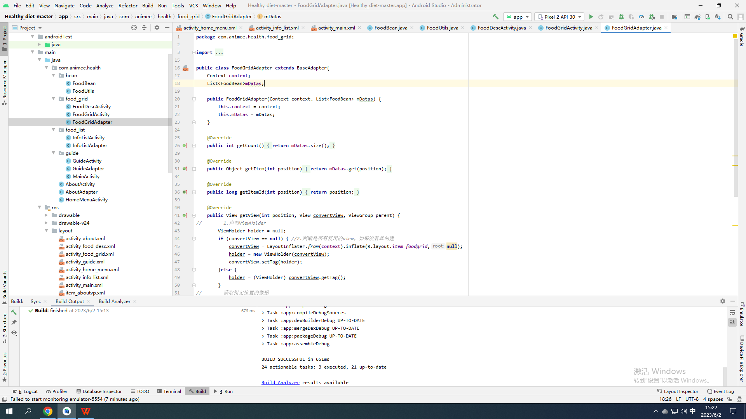

**package** com.animee.health.food_grid;  
  
**import** android.content.Context;  
**import** android.view.LayoutInflater;  
**import** android.view.View;  
**import** android.view.ViewGroup;  
**import** android.widget.BaseAdapter;  
**import** android.widget.ImageView;  
**import** android.widget.TextView;  
  
**import** com.animee.health.R;  
**import** com.animee.health.bean.FoodBean;  
  
**import** java.util.List;  
  
**public class** FoodGridAdapter **extends** BaseAdapter{  
 Context **context**;  
 List<FoodBean>**mDatas**;  
  
 **public** FoodGridAdapter(Context context, List<FoodBean> mDatas) {  
 **this**.**context** = context;  
 **this**.**mDatas** = mDatas;  
 }  
  
 @Override  
 **public int** getCount() {  
 **return mDatas**.size();  
 }  
  
 @Override  
 **public** Object getItem(**int** position) {  
 **return mDatas**.get(position);  
 }  
  
 @Override  
 **public long** getItemId(**int** position) {  
 **return** position;  
 }  
  
 @Override  
 **public** View getView(**int** position, View convertView, ViewGroup parent) {  
*// 1.声明ViewHolder* ViewHolder holder = **null**;  
 **if** (convertView == **null**) { *//2.判断是否有复用的view，如果没有就创建* convertView = LayoutInflater.*from*(**context**).inflate(R.layout.***item_foodgrid***,**null**);  
 holder = **new** ViewHolder(convertView);  
 convertView.setTag(holder);  
 }**else** {  
 holder = (ViewHolder) convertView.getTag();  
 }  
*// 获取指定位置的数据* FoodBean foodBean = **mDatas**.get(position);  
 holder.**iv**.setImageResource(foodBean.getPicId());  
 holder.**tv**.setText(foodBean.getTitle());  
 **return** convertView;  
 }  
  
 **class** ViewHolder{  
 ImageView **iv**;  
 TextView **tv**;  
 **public** ViewHolder(View view){  
 **iv** = view.findViewById(R.id.***item_grid_iv***);  
 **tv** = view.findViewById(R.id.***item_grid_tv***);  
 }  
 }  
}

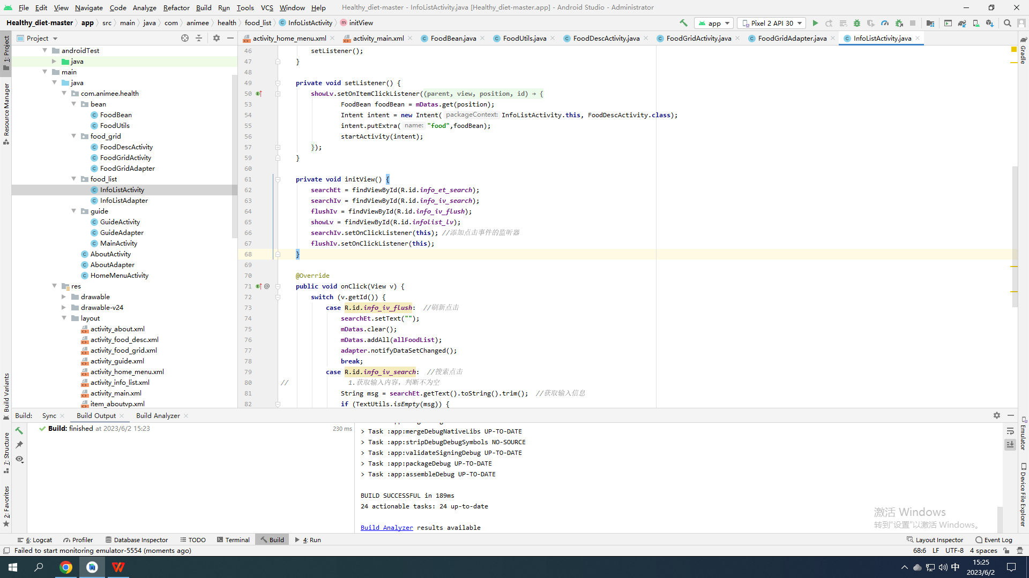

**package** com.animee.health.food_list;  
  
**import** android.content.Intent;  
**import** android.support.v7.app.AppCompatActivity;  
**import** android.os.Bundle;  
**import** android.text.TextUtils;  
**import** android.view.View;  
**import** android.widget.AdapterView;  
**import** android.widget.EditText;  
**import** android.widget.ImageView;  
**import** android.widget.ListView;  
**import** android.widget.Toast;  
  
**import** com.animee.health.R;  
**import** com.animee.health.bean.FoodBean;  
**import** com.animee.health.bean.FoodUtils;  
**import** com.animee.health.food_grid.FoodDescActivity;  
  
**import** java.security.MessageDigest;  
**import** java.util.ArrayList;  
**import** java.util.List;  
  
**public class** InfoListActivity **extends** AppCompatActivity **implements** View.OnClickListener{  
 EditText **searchEt**;  
 ImageView **searchIv**,**flushIv**;  
 ListView **showLv**;  
*// ListView内部数据源* List<FoodBean>**mDatas**;  
 List<FoodBean>**allFoodList**;  
 **private** InfoListAdapter **adapter**;  
  
 @Override  
 **protected void** onCreate(Bundle savedInstanceState) {  
 **super**.onCreate(savedInstanceState);  
 setContentView(R.layout.***activity_info_list***);  
*// 查找控件* initView();  
*// 2.找到ListView对应的数据源* **mDatas** = **new** ArrayList<>();  
 **allFoodList** = FoodUtils.*getAllFoodList*();  
 **mDatas**.addAll(**allFoodList**);  
*// 3.创建适配器 BaseAdapter的子类* **adapter** = **new** InfoListAdapter(**this**, **mDatas**);  
 **showLv**.setAdapter(**adapter**); *//4.设置适配器  
// 设置单向点击监听功能* setListener();  
 }  
  
 **private void** setListener() {  
 **showLv**.setOnItemClickListener(**new** AdapterView.OnItemClickListener() {  
 @Override  
 **public void** onItemClick(AdapterView<?> parent, View view, **int** position, **long** id) {  
 FoodBean foodBean = **mDatas**.get(position);  
 Intent intent = **new** Intent(InfoListActivity.**this**, FoodDescActivity.**class**);  
 intent.putExtra(**"food"**,foodBean);  
 startActivity(intent);  
 }  
 });  
 }  
  
 **private void** initView() {  
 **searchEt** = findViewById(R.id.***info_et_search***);  
 **searchIv** = findViewById(R.id.***info_iv_search***);  
 **flushIv** = findViewById(R.id.***info_iv_flush***);  
 **showLv** = findViewById(R.id.***infolist_lv***);  
 **searchIv**.setOnClickListener(**this**); *//添加点击事件的监听器* **flushIv**.setOnClickListener(**this**);  
 }  
  
 @Override  
 **public void** onClick(View v) {  
 **switch** (v.getId()) {  
 **case** R.id.***info_iv_flush***: *//刷新点击* **searchEt**.setText(**""**);  
 **mDatas**.clear();  
 **mDatas**.addAll(**allFoodList**);  
 **adapter**.notifyDataSetChanged();  
 **break**;  
 **case** R.id.***info_iv_search***: *//搜索点击  
// 1.获取输入内容，判断不为空* String msg = **searchEt**.getText().toString().trim(); *//获取输入信息* **if** (TextUtils.*isEmpty*(msg)) {  
 Toast.*makeText*(**this**,**"输入内容不能为空！"**,Toast.***LENGTH_SHORT***).show();  
 **return**;  
 }  
*// 判断所有食物列表的标题是否包含输入内容，如果包含，就添加到小集合中* List<FoodBean>list = **new** ArrayList<>();  
 **for** (**int** i = 0; i < **allFoodList**.size(); i++) {  
 String title = **allFoodList**.get(i).getTitle();  
 **if** (title.contains(msg)) {  
 list.add(**allFoodList**.get(i));  
 }  
 }  
 **mDatas**.clear(); *// 清空ListView的适配器数据源内容* **mDatas**.addAll(list); *// 添加新的数据到数据源中* **adapter**.notifyDataSetChanged(); *// 提示适配器更新* **break**;  
 }  
 }  
}

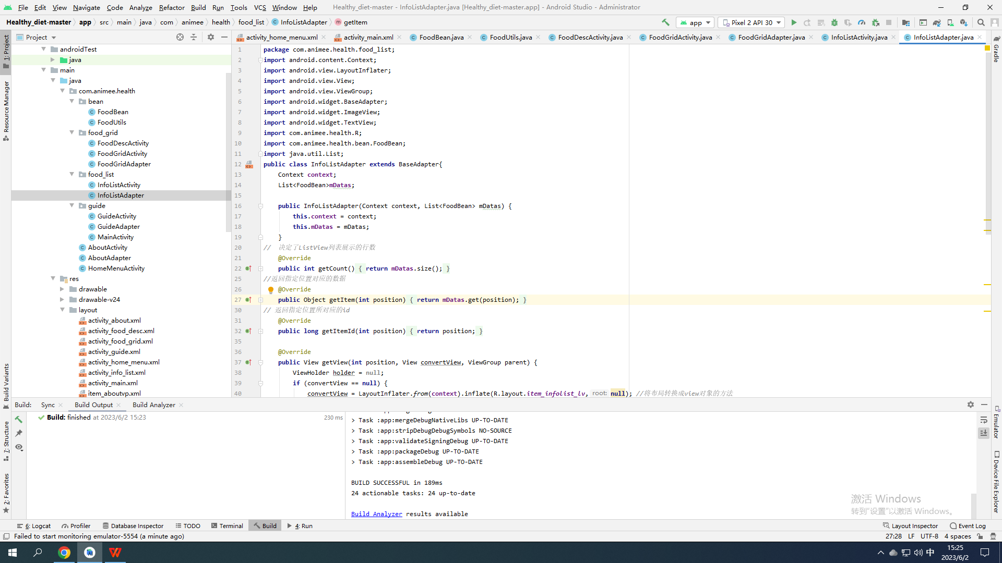

**package** com.animee.health.food_list;  
**import** android.content.Context;  
**import** android.view.LayoutInflater;  
**import** android.view.View;  
**import** android.view.ViewGroup;  
**import** android.widget.BaseAdapter;  
**import** android.widget.ImageView;  
**import** android.widget.TextView;  
**import** com.animee.health.R;  
**import** com.animee.health.bean.FoodBean;  
**import** java.util.List;  
**public class** InfoListAdapter **extends** BaseAdapter{  
 Context **context**;  
 List<FoodBean>**mDatas**;  
  
 **public** InfoListAdapter(Context context, List<FoodBean> mDatas) {  
 **this**.**context** = context;  
 **this**.**mDatas** = mDatas;  
 }  
*// 决定了ListView列表展示的行数* @Override  
 **public int** getCount() {  
 **return mDatas**.size();  
 }  
*//返回指定位置对应的数据* @Override  
 **public** Object getItem(**int** position) {  
 **return mDatas**.get(position);  
 }  
*// 返回指定位置所对应的id* @Override  
 **public long** getItemId(**int** position) {  
 **return** position;  
 }  
  
 @Override  
 **public** View getView(**int** position, View convertView, ViewGroup parent) {  
 ViewHolder holder = **null**;  
 **if** (convertView == **null**) {  
 convertView = LayoutInflater.*from*(**context**).inflate(R.layout.***item_infolist_lv***,**null**); *//将布局转换成view对象的方法* holder=**new** ViewHolder(convertView);  
 convertView.setTag(holder);  
 }**else** {  
 holder = (ViewHolder) convertView.getTag();  
 }  
*// 加载控件显示的内容  
// 获取集合指定位置的数据* FoodBean foodBean = **mDatas**.get(position);  
 holder.**titleTv**.setText(foodBean.getTitle());  
 holder.**notTv**.setText(**"不可匹配:"**+foodBean.getNotmatch());  
 holder.**iv**.setImageResource(foodBean.getPicId());  
 **return** convertView;  
 }  
  
 **class** ViewHolder{  
 ImageView **iv**;  
 TextView **titleTv**,**notTv**;  
 **public** ViewHolder(View view){  
 **iv** = view.findViewById(R.id.***item_info_iv***);  
 **titleTv** = view.findViewById(R.id.***item_info_tv_title***);  
 **notTv** = view.findViewById(R.id.***item_info_tv_notmatch***);  
 }  
 }  
}

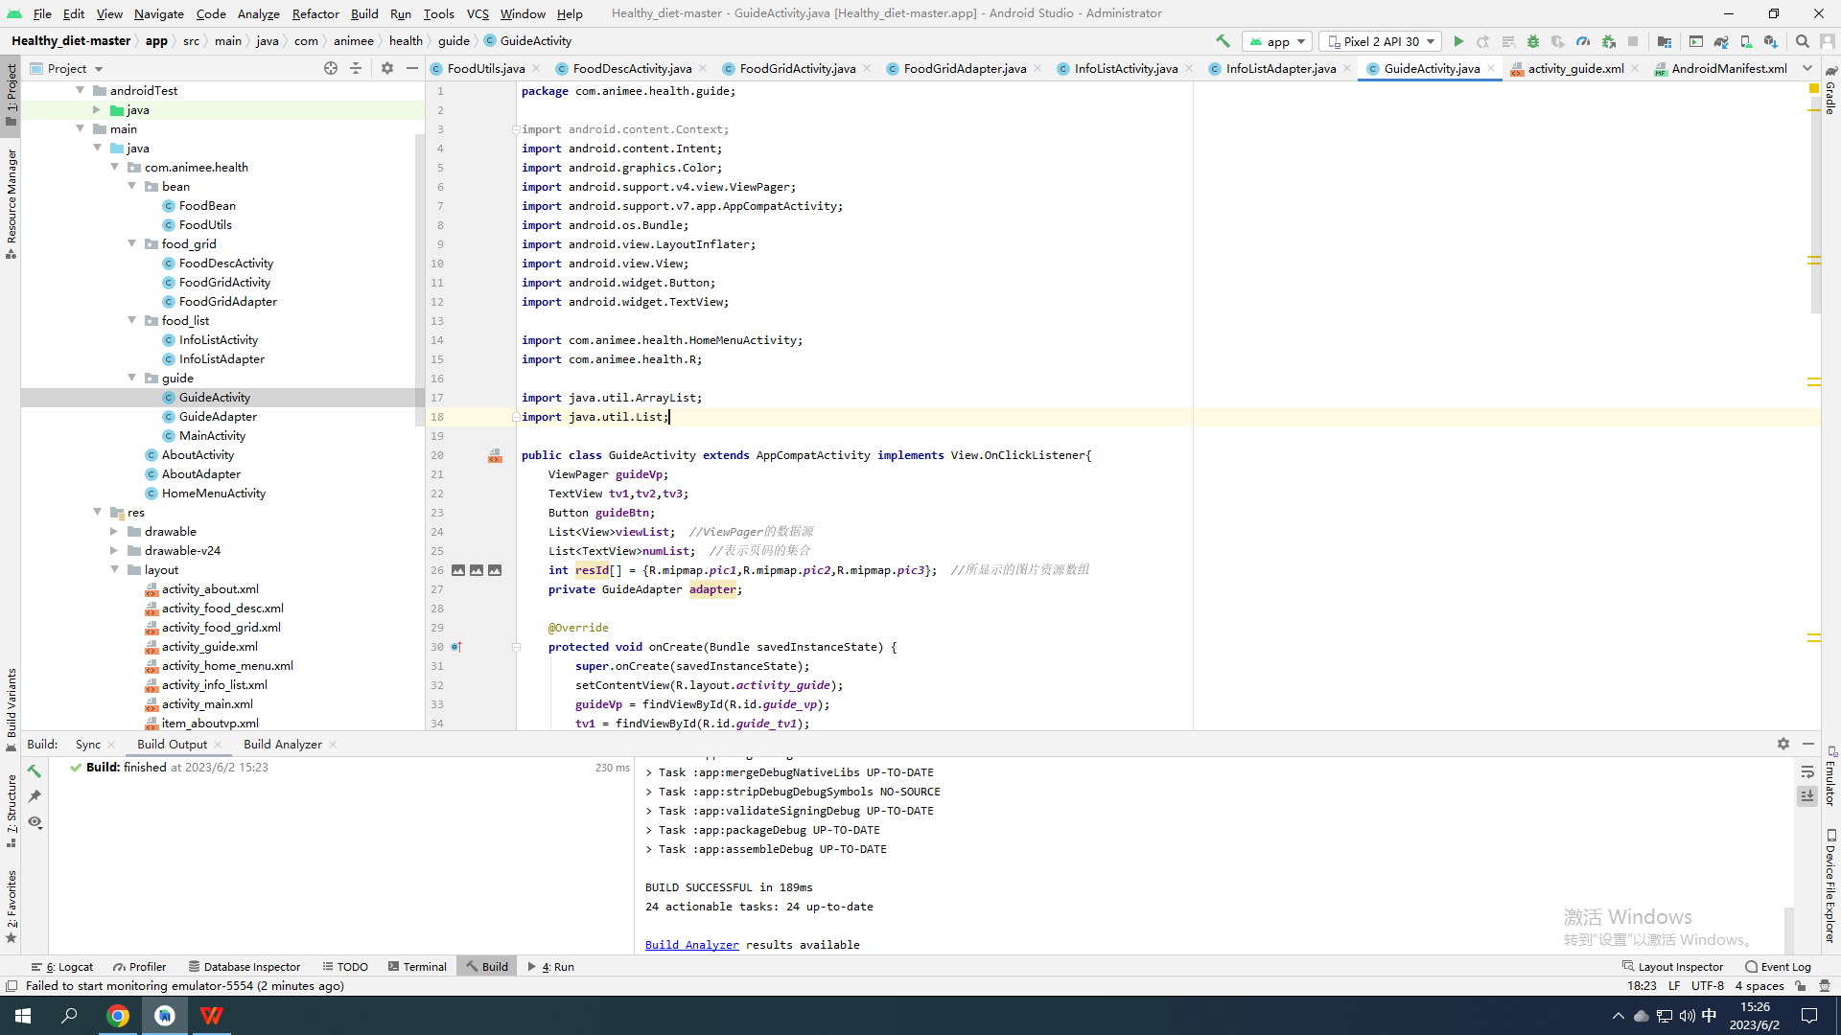

**package** com.animee.health.guide;  
  
**import** android.content.Context;  
**import** android.content.Intent;  
**import** android.graphics.Color;  
**import** android.support.v4.view.ViewPager;  
**import** android.support.v7.app.AppCompatActivity;  
**import** android.os.Bundle;  
**import** android.view.LayoutInflater;  
**import** android.view.View;  
**import** android.widget.Button;  
**import** android.widget.TextView;  
  
**import** com.animee.health.HomeMenuActivity;  
**import** com.animee.health.R;  
  
**import** java.util.ArrayList;  
**import** java.util.List;  
  
**public class** GuideActivity **extends** AppCompatActivity **implements** View.OnClickListener{  
 ViewPager **guideVp**;  
 TextView **tv1**,**tv2**,**tv3**;  
 Button **guideBtn**;  
 List<View>**viewList**; *//ViewPager的数据源* List<TextView>**numList**; *//表示页码的集合* **int resId**[] = {R.mipmap.***pic1***,R.mipmap.***pic2***,R.mipmap.***pic3***}; *//所显示的图片资源数组* **private** GuideAdapter **adapter**;  
  
 @Override  
 **protected void** onCreate(Bundle savedInstanceState) {  
 **super**.onCreate(savedInstanceState);  
 setContentView(R.layout.***activity_guide***);  
 **guideVp** = findViewById(R.id.***guide_vp***);  
 **tv1** = findViewById(R.id.***guide_tv1***);  
 **tv2** = findViewById(R.id.***guide_tv2***);  
 **tv3** = findViewById(R.id.***guide_tv3***);  
 **guideBtn** = findViewById(R.id.***guide_btn***);  
 **guideBtn**.setOnClickListener(**this**); *//设置按钮的监听器* **viewList** = **new** ArrayList<>();  
 **numList** = **new** ArrayList<>();  
 **numList**.add(**tv1**);  
 **numList**.add(**tv2**);  
 **numList**.add(**tv3**);  
*// 初始化ViewPager的页面资源* **for** (**int** i = 0; i < **resId**.**length**; i++) {  
 View view = LayoutInflater.*from*(**this**).inflate(R.layout.***item_guide1***,**null**);  
 view.setBackgroundResource(**resId**[i]);  
 **viewList**.add(view);  
 }  
*// 创建适配器对象* **adapter** = **new** GuideAdapter(**viewList**);  
*// 设置适配器* **guideVp**.setAdapter(**adapter**);  
 **tv1**.setTextColor(Color.***RED***);  
*// 设置ViewPager的监听* setVPListener();  
 }  
  
 **private void** setVPListener() {  
 **guideVp**.addOnPageChangeListener(**new** ViewPager.OnPageChangeListener() {  
 @Override  
 **public void** onPageScrolled(**int** position, **float** positionOffset, **int** positionOffsetPixels) {  
 }  
 @Override  
 **public void** onPageSelected(**int** position) {  
 **for** (**int** i = 0; i < **numList**.size(); i++) {  
 **numList**.get(i).setTextColor(Color.***WHITE***);  
 }  
 **numList**.get(position).setTextColor(Color.***RED***);  
*// 在进入到第三个页面时，立即进入的按钮就显示出来，否则不显示* **if** (position == 2) {  
 **guideBtn**.setVisibility(View.***VISIBLE***);  
 }**else** {  
 **guideBtn**.setVisibility(View.***INVISIBLE***);  
 }  
 }  
 @Override  
 **public void** onPageScrollStateChanged(**int** state) {  
 }  
 });  
 }  
  
 @Override  
 **public void** onClick(View v) {  
 **switch** (v.getId()) {  
 **case** R.id.***guide_btn***:  
 Intent intent = **new** Intent(GuideActivity.**this**, HomeMenuActivity.**class**);  
 startActivity(intent);  
 finish();  
 **break**;  
 }  
 }  
}

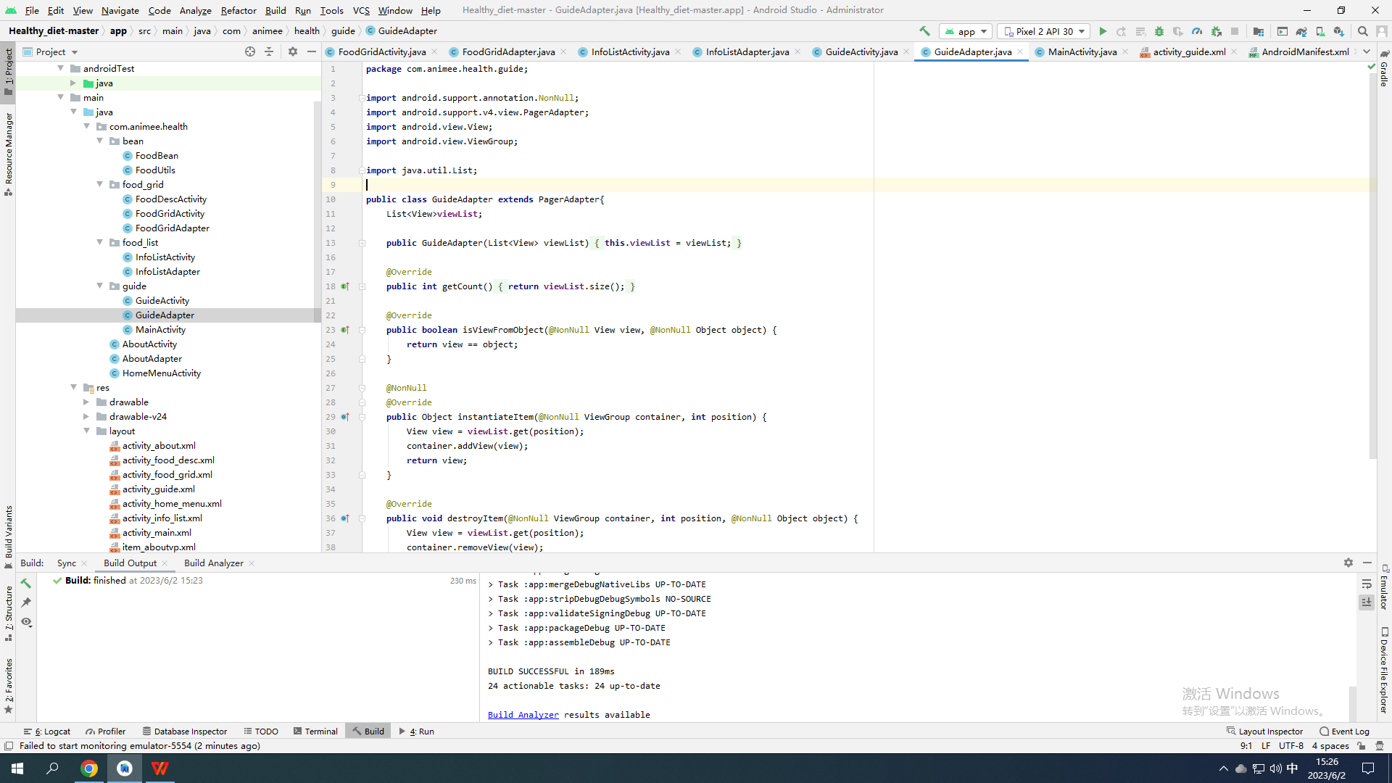

**package** com.animee.health.guide;  
  
**import** android.support.annotation.NonNull;  
**import** android.support.v4.view.PagerAdapter;  
**import** android.view.View;  
**import** android.view.ViewGroup;  
  
**import** java.util.List;  
  
**public class** GuideAdapter **extends** PagerAdapter{  
 List<View>**viewList**;  
  
 **public** GuideAdapter(List<View> viewList) {  
 **this**.**viewList** = viewList;  
 }  
  
 @Override  
 **public int** getCount() {  
 **return viewList**.size();  
 }  
  
 @Override  
 **public boolean** isViewFromObject(@NonNull View view, @NonNull Object object) {  
 **return** view == object;  
 }  
  
 @NonNull  
 @Override  
 **public** Object instantiateItem(@NonNull ViewGroup container, **int** position) {  
 View view = **viewList**.get(position);  
 container.addView(view);  
 **return** view;  
 }  
  
 @Override  
 **public void** destroyItem(@NonNull ViewGroup container, **int** position, @NonNull Object object) {  
 View view = **viewList**.get(position);  
 container.removeView(view);  
 }  
}

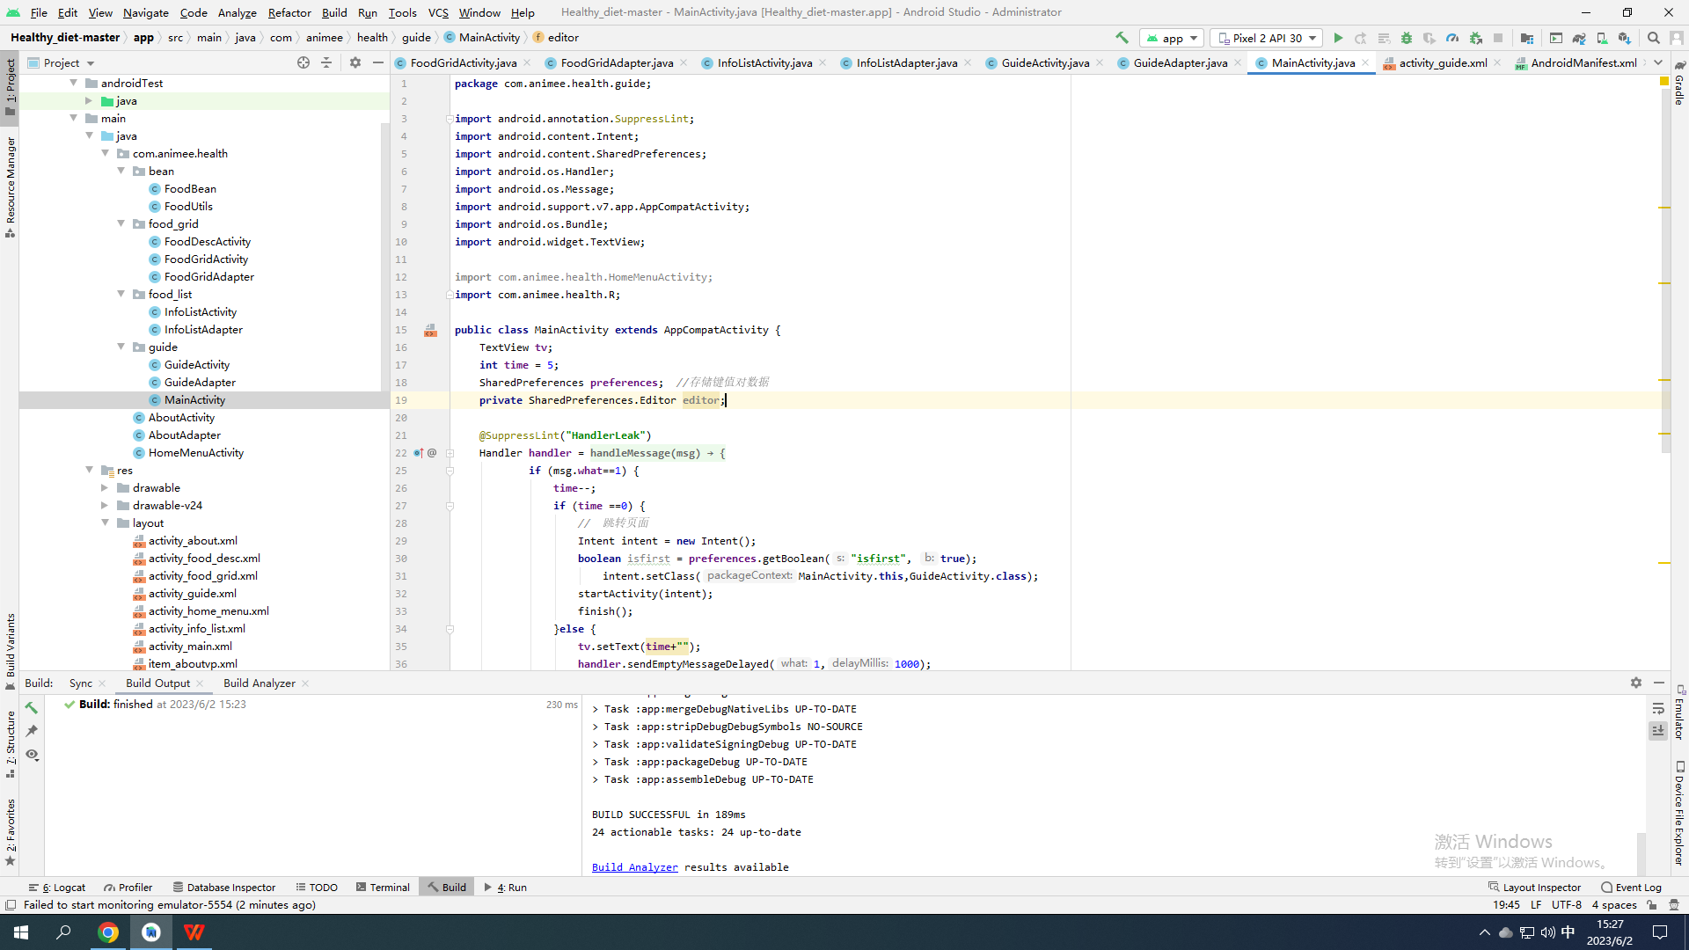

**package** com.animee.health.guide;  
  
**import** android.annotation.SuppressLint;  
**import** android.content.Intent;  
**import** android.content.SharedPreferences;  
**import** android.os.Handler;  
**import** android.os.Message;  
**import** android.support.v7.app.AppCompatActivity;  
**import** android.os.Bundle;  
**import** android.widget.TextView;  
  
**import** com.animee.health.HomeMenuActivity;  
**import** com.animee.health.R;  
  
**public class** MainActivity **extends** AppCompatActivity {  
 TextView **tv**;  
 **int time** = 5;  
 SharedPreferences **preferences**; *//存储键值对数据* **private** SharedPreferences.Editor **editor**;  
  
 @SuppressLint(**"HandlerLeak"**)  
 Handler **handler** = **new** Handler(){  
 @Override  
 **public void** handleMessage(Message msg) {  
 **if** (msg.**what**==1) {  
 **time**--;  
 **if** (**time** ==0) {  
 *// 跳转页面* Intent intent = **new** Intent();  
 **boolean** isfirst = **preferences**.getBoolean(**"isfirst"**, **true**);  
 intent.setClass(MainActivity.**this**,GuideActivity.**class**);  
 startActivity(intent);  
 finish();  
 }**else** {  
 **tv**.setText(**time**+**""**);  
 **handler**.sendEmptyMessageDelayed(1,1000);  
 }  
 }  
 }  
 };  
  
 @Override  
 **protected void** onCreate(Bundle savedInstanceState) {  
 **super**.onCreate(savedInstanceState);  
 setContentView(R.layout.***activity_main***);  
 **tv** = findViewById(R.id.***main_tv***);  
 **preferences** = getSharedPreferences(**"health_pref"**,***MODE_PRIVATE***);  
 **editor** = **preferences**.edit(); *//写入数据的对象* **handler**.sendEmptyMessageDelayed(1,1000);  
 }  
}

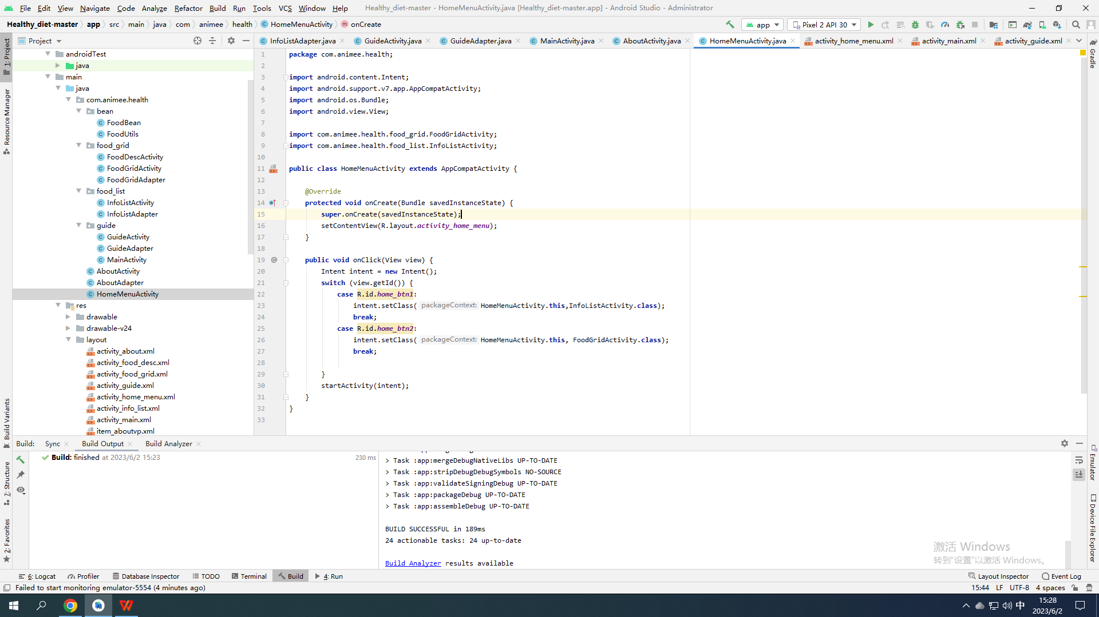

**package** com.animee.health;  
  
**import** android.content.Intent;  
**import** android.support.v7.app.AppCompatActivity;  
**import** android.os.Bundle;  
**import** android.view.View;  
  
**import** com.animee.health.food_grid.FoodGridActivity;  
**import** com.animee.health.food_list.InfoListActivity;  
  
**public class** HomeMenuActivity **extends** AppCompatActivity {  
  
 @Override  
 **protected void** onCreate(Bundle savedInstanceState) {  
 **super**.onCreate(savedInstanceState);  
 setContentView(R.layout.***activity_home_menu***);  
 }  
  
 **public void** onClick(View view) {  
 Intent intent = **new** Intent();  
 **switch** (view.getId()) {  
 **case** R.id.***home_btn1***:  
 intent.setClass(HomeMenuActivity.**this**,InfoListActivity.**class**);  
 **break**;  
 **case** R.id.***home_btn2***:  
 intent.setClass(HomeMenuActivity.**this**, FoodGridActivity.**class**);  
 **break**;  
  
 }  
 startActivity(intent);  
 }  
}

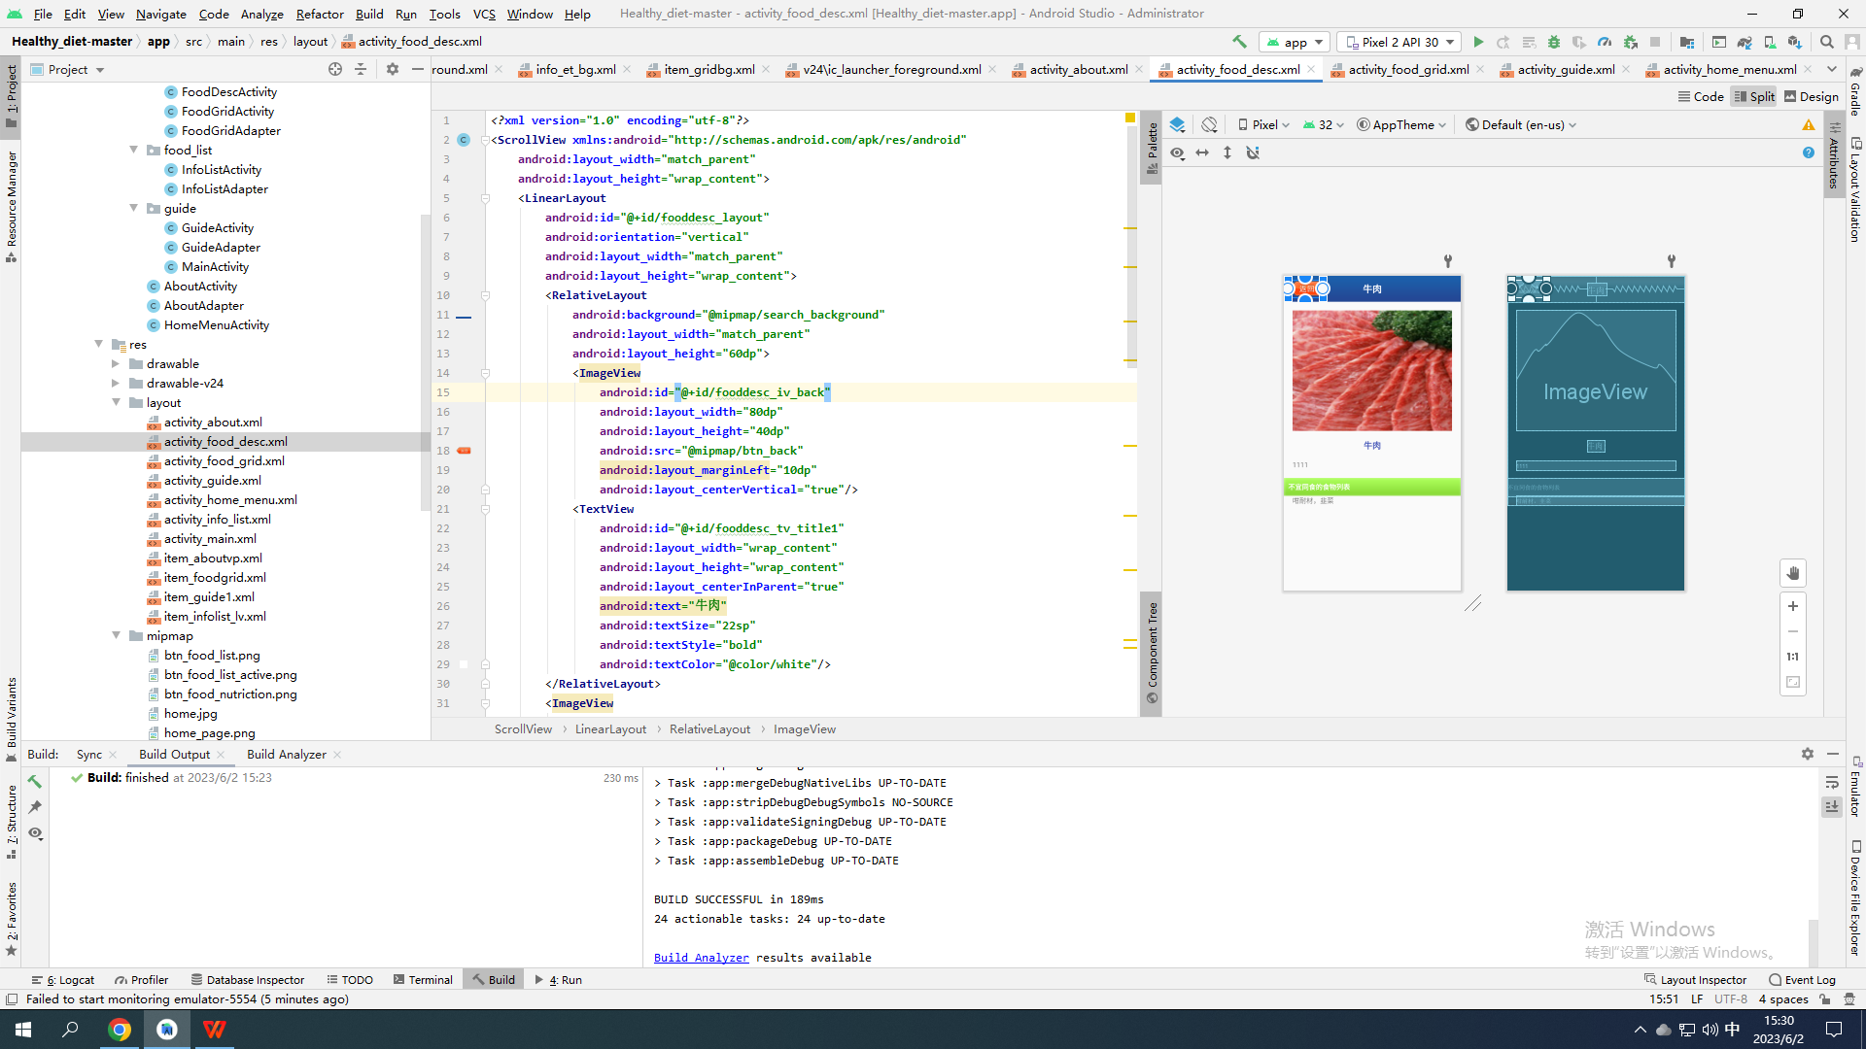

*<?***xml version="1.0" encoding="utf-8"***?>*<**ScrollView xmlns:android="http://schemas.android.com/apk/res/android"  
 android:layout_width="match_parent"  
 android:layout_height="wrap_content"**>  
 <**LinearLayout  
 android:id="@+id/fooddesc_layout"  
 android:orientation="vertical"  
 android:layout_width="match_parent"  
 android:layout_height="wrap_content"**>  
 <**RelativeLayout  
 android:background="@mipmap/search_background"  
 android:layout_width="match_parent"  
 android:layout_height="60dp"**>  
 <**ImageView  
 android:id="@+id/fooddesc_iv_back"  
 android:layout_width="80dp"  
 android:layout_height="40dp"  
 android:src="@mipmap/btn_back"  
 android:layout_marginLeft="10dp"  
 android:layout_centerVertical="true"**/>  
 <**TextView  
 android:id="@+id/fooddesc_tv_title1"  
 android:layout_width="wrap_content"  
 android:layout_height="wrap_content"  
 android:layout_centerInParent="true"  
 android:text="牛肉"  
 android:textSize="22sp"  
 android:textStyle="bold"  
 android:textColor="@color/white"**/>  
 </**RelativeLayout**>  
 <**ImageView  
 android:id="@+id/fooddesc_iv_bigpic"  
 android:layout_width="match_parent"  
 android:layout_height="280dp"  
 android:src="@mipmap/beef"  
 android:layout_margin="20sp"  
 android:scaleType="fitXY"**/>  
 <**TextView  
 android:id="@+id/fooddesc_tv_title2"  
 android:layout_width="wrap_content"  
 android:layout_height="wrap_content"  
 android:text="牛肉"  
 android:textColor="@color/colorPrimary"  
 android:textStyle="bold"  
 android:layout_gravity="center"  
 android:textSize="20sp"**/>  
 <**TextView  
 android:id="@+id/fooddesc_tv_desc"  
 android:layout_width="match_parent"  
 android:layout_height="wrap_content"  
 android:text="1111"  
 android:layout_margin="20dp"  
 android:textSize="16sp"**/>  
 <**TextView  
 android:layout_width="match_parent"  
 android:layout_height="wrap_content"  
 android:background="@mipmap/food_info_middle_background"  
 android:text="不宜同食的食物列表"  
 android:padding="10dp"  
 android:textSize="16sp"  
 android:textColor="@color/white"  
 android:textStyle="bold"**/>  
 <**TextView  
 android:id="@+id/fooddesc_tv_not"  
 android:layout_width="match_parent"  
 android:layout_height="wrap_content"  
 android:text="咁耐材，韭菜"  
 android:layout_marginLeft="20dp"  
 android:textSize="16sp"**/>  
 </**LinearLayout**>  
</**ScrollView**>

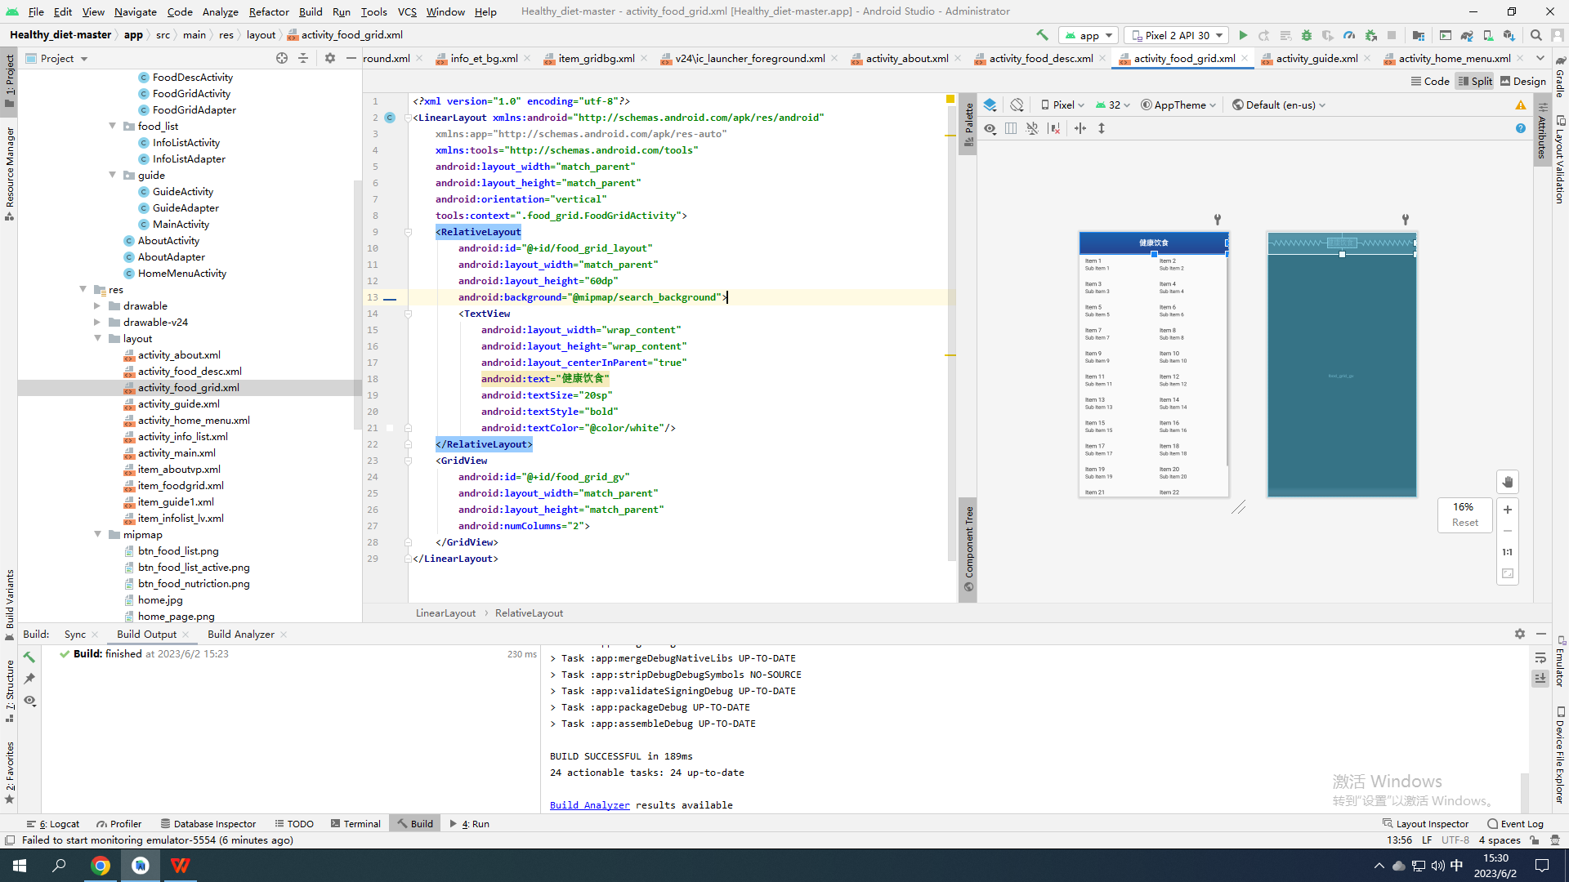

*<?***xml version="1.0" encoding="utf-8"***?>*<**LinearLayout xmlns:android="http://schemas.android.com/apk/res/android"  
 xmlns:app="http://schemas.android.com/apk/res-auto"  
 xmlns:tools="http://schemas.android.com/tools"  
 android:layout_width="match_parent"  
 android:layout_height="match_parent"  
 android:orientation="vertical"  
 tools:context=".food_grid.FoodGridActivity"**>  
 <**RelativeLayout  
 android:id="@+id/food_grid_layout"  
 android:layout_width="match_parent"  
 android:layout_height="60dp"  
 android:background="@mipmap/search_background"**>  
 <**TextView  
 android:layout_width="wrap_content"  
 android:layout_height="wrap_content"  
 android:layout_centerInParent="true"  
 android:text="健康饮食"  
 android:textSize="20sp"  
 android:textStyle="bold"  
 android:textColor="@color/white"**/>  
 </**RelativeLayout**>  
 <**GridView  
 android:id="@+id/food_grid_gv"  
 android:layout_width="match_parent"  
 android:layout_height="match_parent"  
 android:numColumns="2"**>  
 </**GridView**>  
</**LinearLayout**>

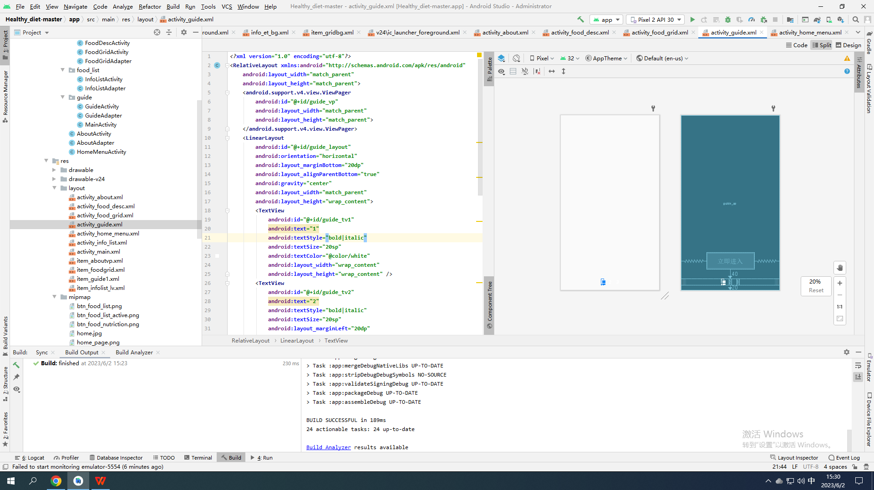

*<?***xml version="1.0" encoding="utf-8"***?>*<**RelativeLayout xmlns:android="http://schemas.android.com/apk/res/android"  
 android:layout_width="match_parent"  
 android:layout_height="match_parent"**>  
 <**android.support.v4.view.ViewPager  
 android:id="@+id/guide_vp"  
 android:layout_width="match_parent"  
 android:layout_height="match_parent"**>  
 </**android.support.v4.view.ViewPager**>  
 <**LinearLayout  
 android:id="@+id/guide_layout"  
 android:orientation="horizontal"  
 android:layout_marginBottom="20dp"  
 android:layout_alignParentBottom="true"  
 android:gravity="center"  
 android:layout_width="match_parent"  
 android:layout_height="wrap_content"**>  
 <**TextView  
 android:id="@+id/guide_tv1"  
 android:text="1"  
 android:textStyle="bold|italic"  
 android:textSize="20sp"  
 android:textColor="@color/white"  
 android:layout_width="wrap_content"  
 android:layout_height="wrap_content"** />  
 <**TextView  
 android:id="@+id/guide_tv2"  
 android:text="2"  
 android:textStyle="bold|italic"  
 android:textSize="20sp"  
 android:layout_marginLeft="20dp"  
 android:layout_marginRight="20dp"  
 android:layout_width="wrap_content"  
 android:textColor="@color/white"  
 android:layout_height="wrap_content"** />  
 <**TextView  
 android:id="@+id/guide_tv3"  
 android:text="3"  
 android:textStyle="bold|italic"  
 android:textSize="20sp"  
 android:textColor="@color/white"  
 android:layout_width="wrap_content"  
 android:layout_height="wrap_content"** />  
 </**LinearLayout**>  
 <**Button  
 android:id="@+id/guide_btn"  
 android:layout_width="200dp"  
 android:layout_height="70dp"  
 android:layout_above="@id/guide_layout"  
 android:layout_centerHorizontal="true"  
 android:background="@mipmap/search_background"  
 android:text="立即进入"  
 android:textColor="@color/white"  
 android:textSize="30sp"  
 android:textStyle="bold"  
 android:layout_marginBottom="40dp"  
 android:visibility="invisible"**/>  
</**RelativeLayout**>

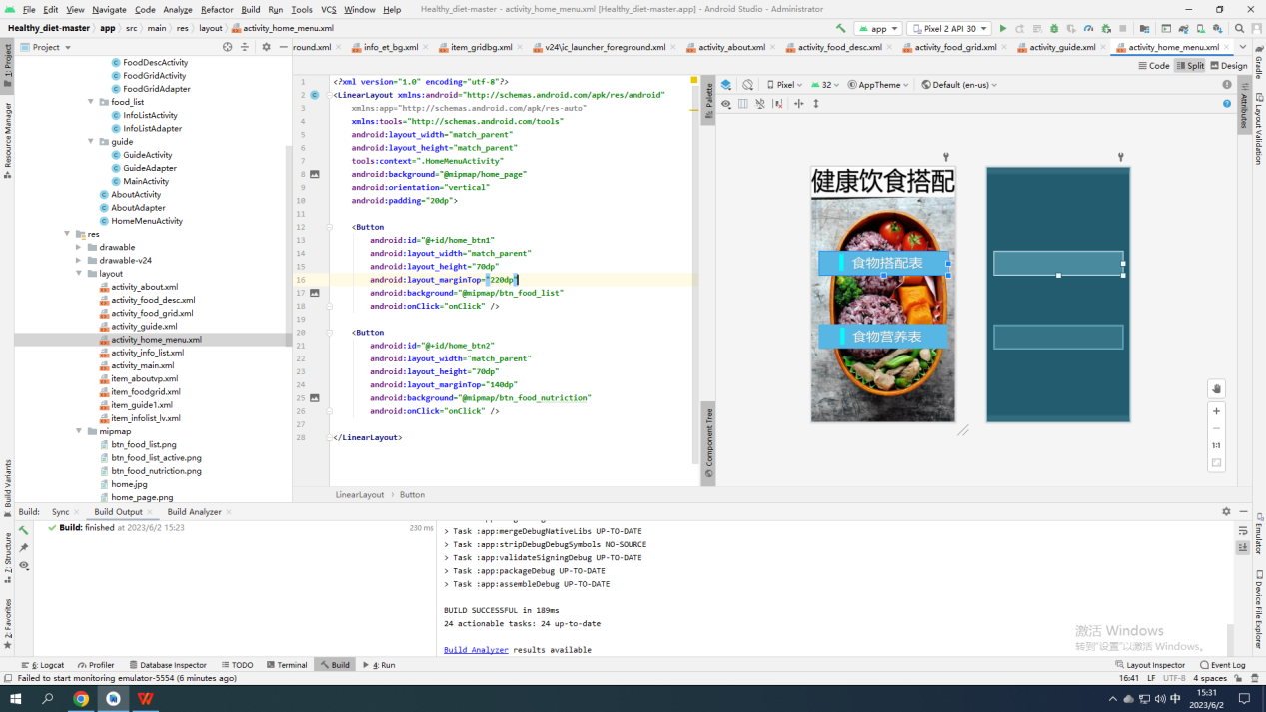

*<?***xml version="1.0" encoding="utf-8"***?>*<**LinearLayout xmlns:android="http://schemas.android.com/apk/res/android"  
 xmlns:app="http://schemas.android.com/apk/res-auto"  
 xmlns:tools="http://schemas.android.com/tools"  
 android:layout_width="match_parent"  
 android:layout_height="match_parent"  
 tools:context=".HomeMenuActivity"  
 android:background="@mipmap/home_page"  
 android:orientation="vertical"  
 android:padding="20dp"**>  
  
 <**Button  
 android:id="@+id/home_btn1"  
 android:layout_width="match_parent"  
 android:layout_height="70dp"  
 android:layout_marginTop="220dp"  
 android:background="@mipmap/btn_food_list"  
 android:onClick="onClick"** />  
  
 <**Button  
 android:id="@+id/home_btn2"  
 android:layout_width="match_parent"  
 android:layout_height="70dp"  
 android:layout_marginTop="140dp"  
 android:background="@mipmap/btn_food_nutriction"  
 android:onClick="onClick"** />  
  
</**LinearLayout**>

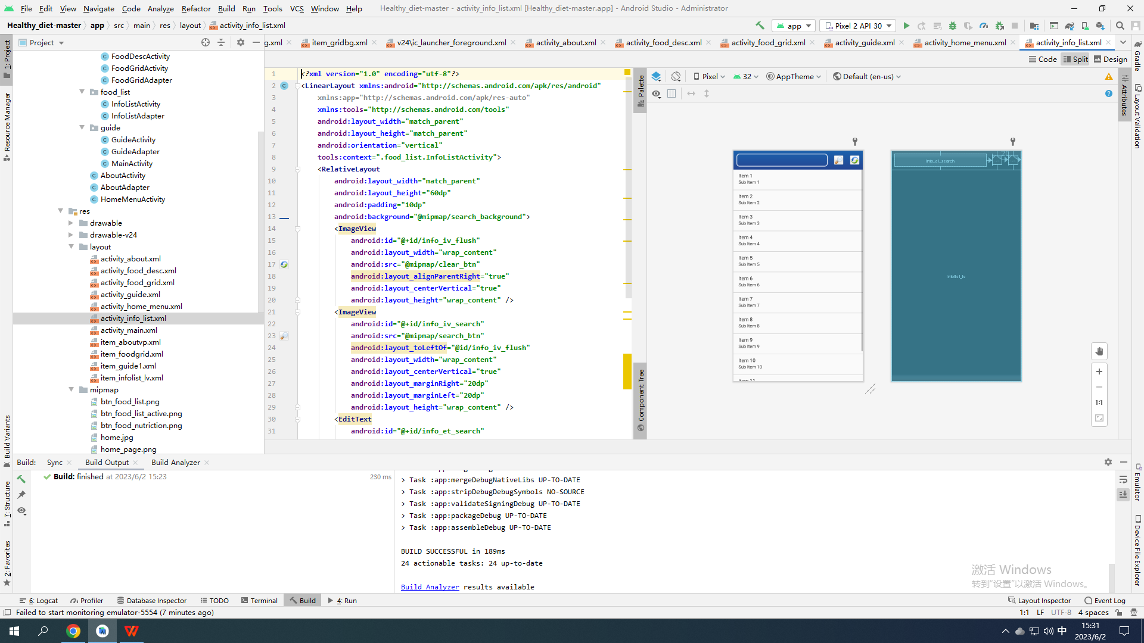

*<?***xml version="1.0" encoding="utf-8"***?>*<**LinearLayout xmlns:android="http://schemas.android.com/apk/res/android"  
 xmlns:app="http://schemas.android.com/apk/res-auto"  
 xmlns:tools="http://schemas.android.com/tools"  
 android:layout_width="match_parent"  
 android:layout_height="match_parent"  
 android:orientation="vertical"  
 tools:context=".food_list.InfoListActivity"**>  
 <**RelativeLayout  
 android:layout_width="match_parent"  
 android:layout_height="60dp"  
 android:padding="10dp"  
 android:background="@mipmap/search_background"**>  
 <**ImageView  
 android:id="@+id/info_iv_flush"  
 android:layout_width="wrap_content"  
 android:src="@mipmap/clear_btn"  
 android:layout_alignParentRight="true"  
 android:layout_centerVertical="true"  
 android:layout_height="wrap_content"** />  
 <**ImageView  
 android:id="@+id/info_iv_search"  
 android:src="@mipmap/search_btn"  
 android:layout_toLeftOf="@id/info_iv_flush"  
 android:layout_width="wrap_content"  
 android:layout_centerVertical="true"  
 android:layout_marginRight="20dp"  
 android:layout_marginLeft="20dp"  
 android:layout_height="wrap_content"** />  
 <**EditText  
 android:id="@+id/info_et_search"  
 android:layout_width="match_parent"  
 android:layout_height="match_parent"  
 android:layout_toLeftOf="@id/info_iv_search"  
 android:paddingLeft="20dp"  
 android:background="@drawable/info_et_bg"  
 android:layout_centerVertical="true"  
 android:textColor="@color/white"**/>  
 </**RelativeLayout**>  
 <**ListView  
 android:id="@+id/infolist_lv"  
 android:layout_width="match_parent"  
 android:layout_height="match_parent"  
 android:divider="@color/dividerColor"  
 android:dividerHeight="1dp"**></**ListView**>  
</**LinearLayout**>

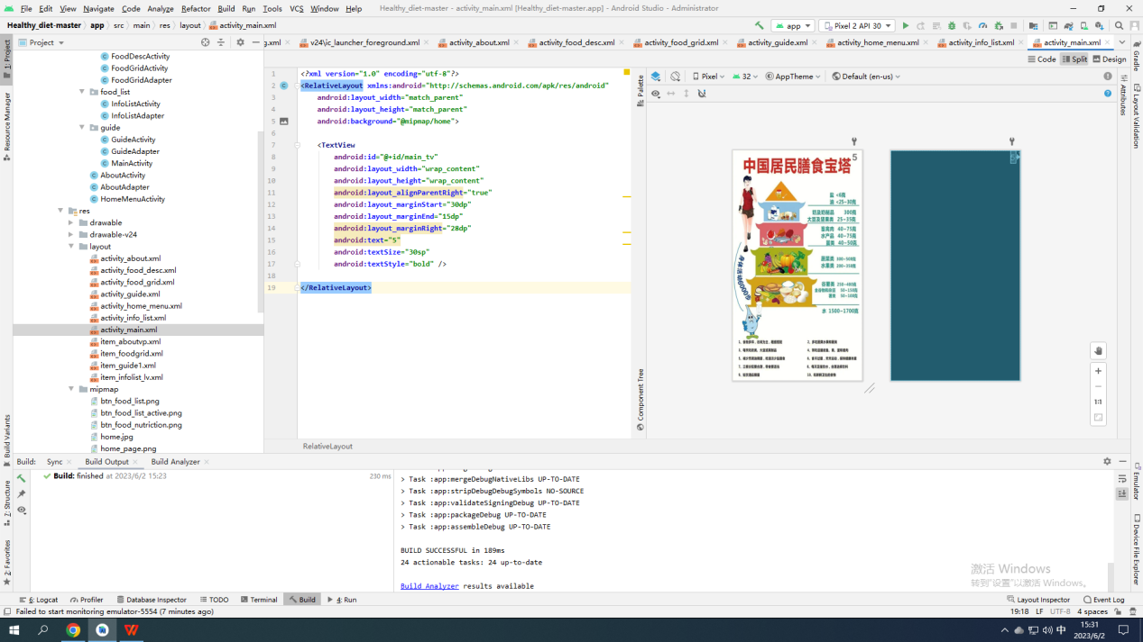*<?***xml version="1.0" encoding="utf-8"***?>*<**RelativeLayout xmlns:android="http://schemas.android.com/apk/res/android"  
 android:layout_width="match_parent"  
 android:layout_height="match_parent"  
 android:background="@mipmap/home"**>  
  
 <**TextView  
 android:id="@+id/main_tv"  
 android:layout_width="wrap_content"  
 android:layout_height="wrap_content"  
 android:layout_alignParentRight="true"  
 android:layout_marginStart="30dp"  
 android:layout_marginEnd="15dp"  
 android:layout_marginRight="28dp"  
 android:text="5"  
 android:textSize="30sp"  
 android:textStyle="bold"** />  
  
</**RelativeLayout**>

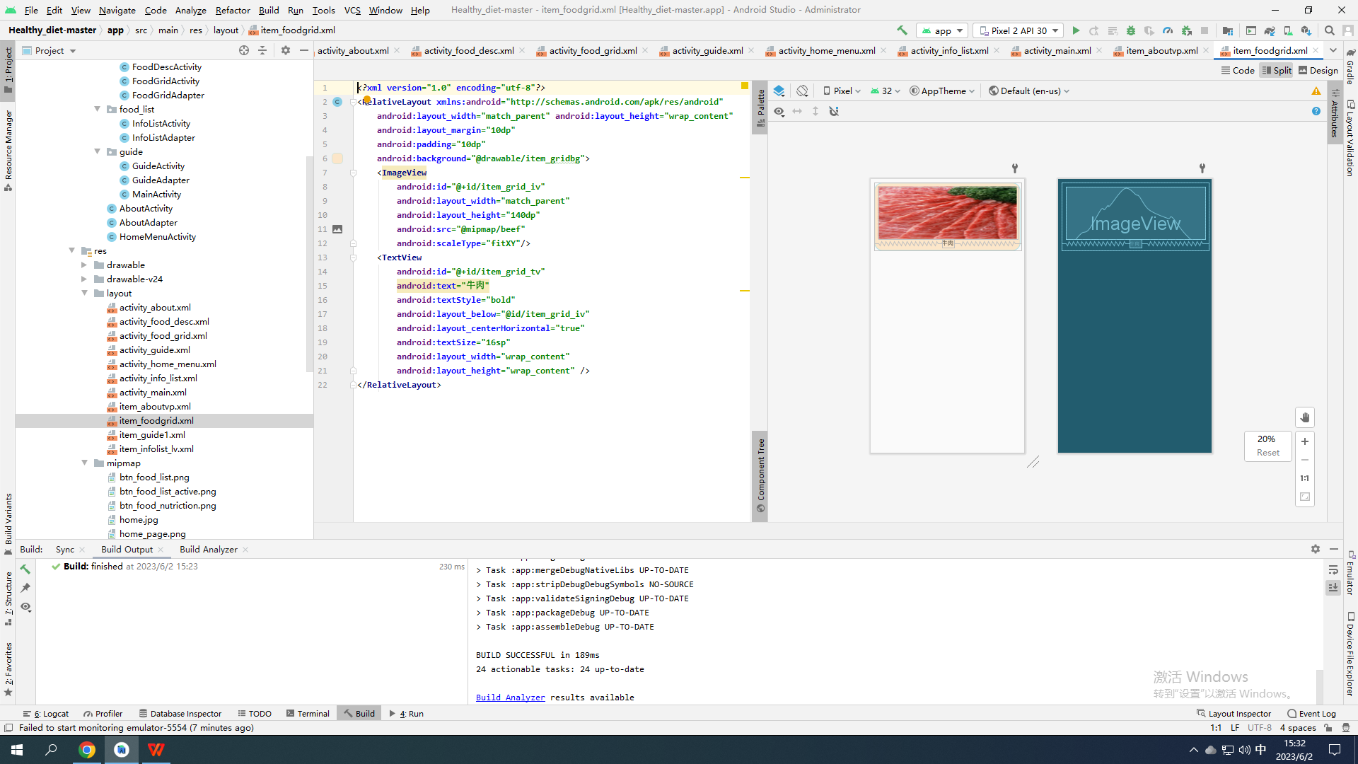*<?***xml version="1.0" encoding="utf-8"***?>*<**RelativeLayout xmlns:android="http://schemas.android.com/apk/res/android"  
 android:layout_width="match_parent" android:layout_height="wrap_content"  
 android:layout_margin="10dp"  
 android:padding="10dp"  
 android:background="@drawable/item_gridbg"**>  
 <**ImageView  
 android:id="@+id/item_grid_iv"  
 android:layout_width="match_parent"  
 android:layout_height="140dp"  
 android:src="@mipmap/beef"  
 android:scaleType="fitXY"**/>  
 <**TextView  
 android:id="@+id/item_grid_tv"  
 android:text="牛肉"  
 android:textStyle="bold"  
 android:layout_below="@id/item_grid_iv"  
 android:layout_centerHorizontal="true"  
 android:textSize="16sp"  
 android:layout_width="wrap_content"  
 android:layout_height="wrap_content"** />  
</**RelativeLayout**>

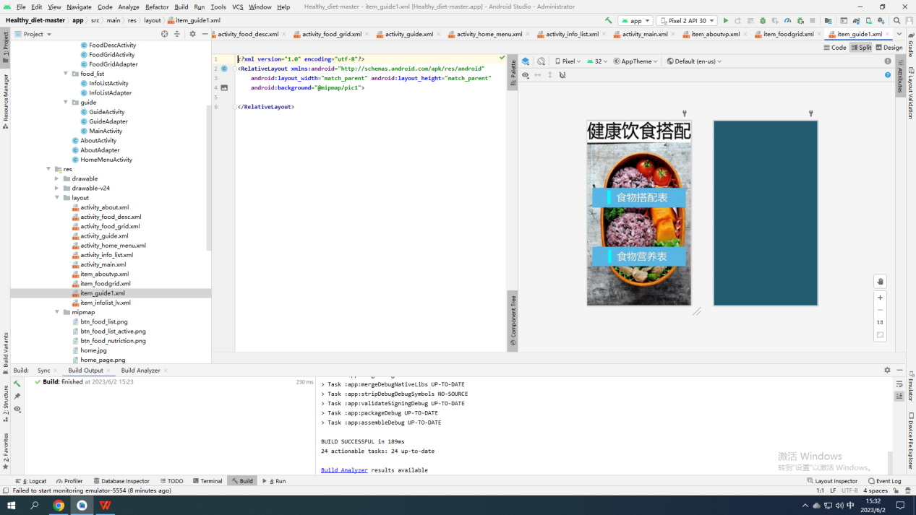

*<?***xml version="1.0" encoding="utf-8"***?>*<**RelativeLayout xmlns:android="http://schemas.android.com/apk/res/android"  
 android:layout_width="match_parent" android:layout_height="match_parent"  
 android:background="@mipmap/pic1"**>  
  
</**RelativeLayout**>

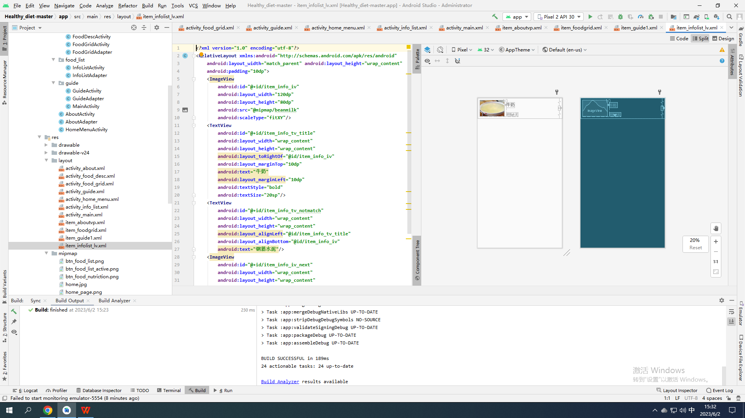*<?***xml version="1.0" encoding="utf-8"***?>*<**RelativeLayout xmlns:android="http://schemas.android.com/apk/res/android"  
 android:layout_width="match_parent" android:layout_height="wrap_content"  
 android:padding="10dp"**>  
 <**ImageView  
 android:id="@+id/item_info_iv"  
 android:layout_width="120dp"  
 android:layout_height="80dp"  
 android:src="@mipmap/beanmilk"  
 android:scaleType="fitXY"**/>  
 <**TextView  
 android:id="@+id/item_info_tv_title"  
 android:layout_width="wrap_content"  
 android:layout_height="wrap_content"  
 android:layout_toRightOf="@id/item_info_iv"  
 android:layout_marginTop="10dp"  
 android:text="牛奶"  
 android:layout_marginLeft="10dp"  
 android:textStyle="bold"  
 android:textSize="20sp"**/>  
 <**TextView  
 android:id="@+id/item_info_tv_notmatch"  
 android:layout_width="wrap_content"  
 android:layout_height="wrap_content"  
 android:layout_alignLeft="@id/item_info_tv_title"  
 android:layout_alignBottom="@id/item_info_iv"  
 android:text="钢筋水泥"**/>  
 <**ImageView  
 android:id="@+id/item_info_iv_next"  
 android:layout_width="wrap_content"  
 android:layout_height="wrap_content"  
 android:src="@mipmap/expand"  
 android:layout_alignParentRight="true"  
 android:layout_centerVertical="true"**/>  
</**RelativeLayout**>